Creating a Web Page with Map, Hotspot, Frames, and Links and Applying Embedded, External, and Inline CSS in a Web Page
EXP:1

AIM:
To design a web page with an embedded map, hotspots, frames, and navigation links.
To demonstrate the use of embedded, external, and inline CSS styles.

CODE:
Hotspot.html
<!DOCTYPE html>
<html>
<head>
<title>Hotspot</title>
<!-- Link to the external CSS file -->
<link rel="stylesheet" type="text/css" href="style.css">
<style>
h1 {
text-align: center;
color: #333;
margin-top: 20px;
}
</style>
</head>
<body>

<h1>Interactive Map of India</h1>

<img src="india map.webp" usemap="#indiamap" width="900" height="720" alt="Map of India">

<map name="indiamap">
<area shape="rect" coords="324,578,407,535" alt="Tamil Nadu" href="https://en.wikipedia.org/wiki/Tamil_Nadu">
<area shape="rect" coords="343,655,398,599" alt="Tamil Nadu" href="https://en.wikipedia.org/wiki/Tamil_Nadu">
<area shape="rect" coords="407,538,395,602" alt="Tamil Nadu" href="https://en.wikipedia.org/wiki/Tamil_Nadu">
<area shape="rect" coords="346,653,397,605" alt="Tamil Nadu" href="https://en.wikipedia.org/wiki/Tamil_Nadu">
<area shape="rect" coords="406,537,324,579" alt="Tamil Nadu" href="https://en.wikipedia.org/wiki/Tamil_Nadu">
</map>

</body>
</html>

OUTPUT:

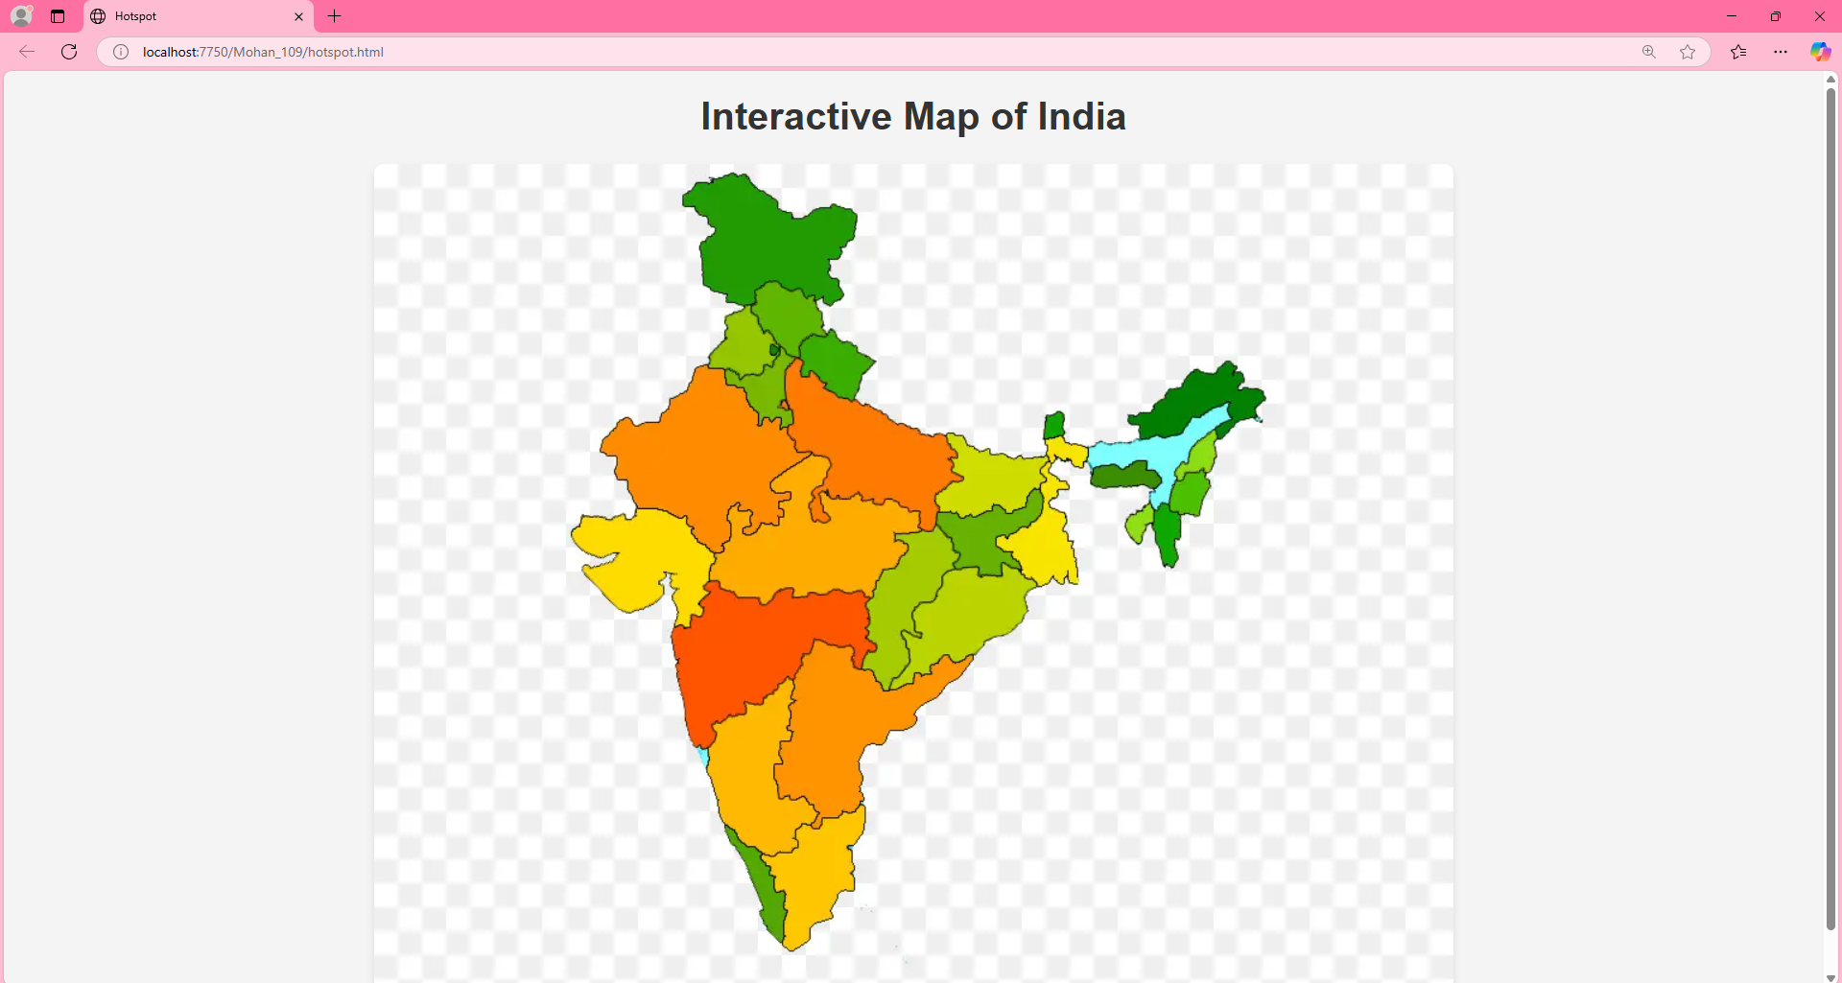

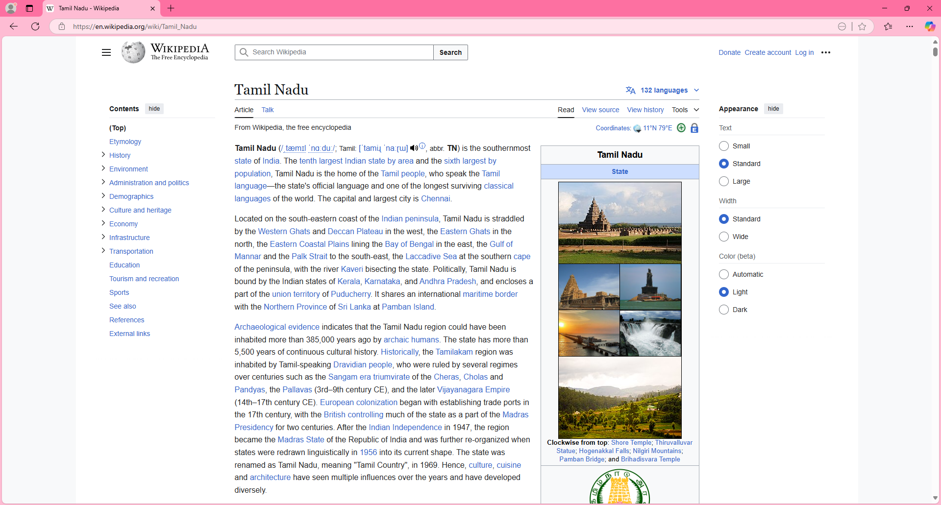

RESULT:
Validating the username and age is done successfully and displayed in the browser.

